FOR IMMEDIATE RELEASE
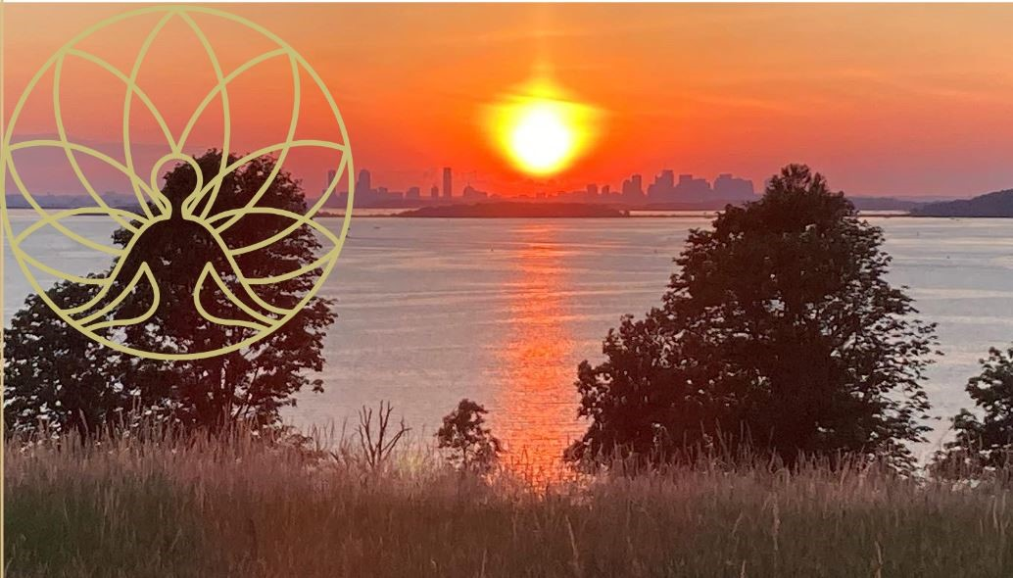

Anne Smith-White | Regional Vice President, Southeast & Islands | 781.259.3655| asmithwhite@thetrustees.org

The Trustees hosts Second Annual Wellness Retreat, Saturday, June 29
An evening of connection, clarity and renewal at the top of World’s End in Hingham

HINGHAM, MA – June 19, 2024 – The Trustees of Reservations (The Trustees) today announces a World’s End Wellness Retreat to take place on Saturday, June 29, 5-8:30PM at World’s End Reservation in Hingham, 0 Martin’s Lane. Rain date Sunday, June 30.

The top of Planter’s Hill on the spectacular World’s End peninsula is the sight of an evening of connection, clarity and renewal led by an inspirational team of wellness experts.

As the sun sets over Boston Harbor and the city skyline, guests are invited craft their experience from a range of therapeutic modalities such as yoga, sound healing, drumming, Reiki, and guided meditation. The evening opens with a community drumming convocation at 5PM and closes with sunset meditation at 8:30PM. In between, participants experience two 45-minute guided experiences, enjoy a picnic, or hike out onto the property. Our friends from Independent Fermentations will be serving craft kombucha. This wellness retreat is appropriate for everybody (over the age of 15) and every body.

PROGRAM
5 – 5:45PM Convocation and Community Drum Circle
6 – 6:45PM First session, 7 – 7:45PM Second session
- Heart & Soul Yoga - Revive, renew, and relax during this heartfelt yoga class where we will open with slow-paced movements in sync with the breath, to experience strength in the body and clarity of the mind. Appropriate for all experience levels.
- Sound Bath – This nature-based sound bath combines the talent of two sound healing practitioners who will integrate the tranquil tones of Himalayan metals and crystal bowls with birdsong and wind in the leaves.
- Mindful Hike – Ground yourself in your senses during this restorative walk along the grassy paths of the second drumlin.
- Reiki and Sound Healing - 10-minute mini sessions
8 – 8:30PM Sunset meditation

PRACTITIONERS & LEADERS:
Drumming - Ed Sorrentino, South Shore Conservatory Creative Arts Therapies
Yoga - Susanne Hallisey and Beverly Bielewicz, Open Doors Yoga
Sound Bath - Jennifer Petty, White Wave Wellness, and Tara McCarthy, Prakriti Healing & Wellness
Reiki and Sound Healing - Lauren Anthony, Release Reiki Healing
Walking Meditation – Trustees staff

Guests should dress comfortably in layers and bring whatever props they’d like to use (we recommend a yoga mat or towel, reusable water bottle, journal, beach chair, and bug spray.) Picnics are encouraged - no food will be provided. Field parking about a ¼-mile walk from the top of the hill. For questions about accessibility, please contact Anne at asmithwhite@thetrutsees.org.

Reset your nervous system. Move. Be still. Connect with friends. Breathe deeply. Reinvigorate your senses in a place of incredible natural beauty as dusk falls and the first stars light up the sky. We welcome you to World’s End!

